# **5 origin stories of The Joker that will send chills down the spine**

By MANISH MANDAL

### **He’s a war veteran suffering from PTSD**

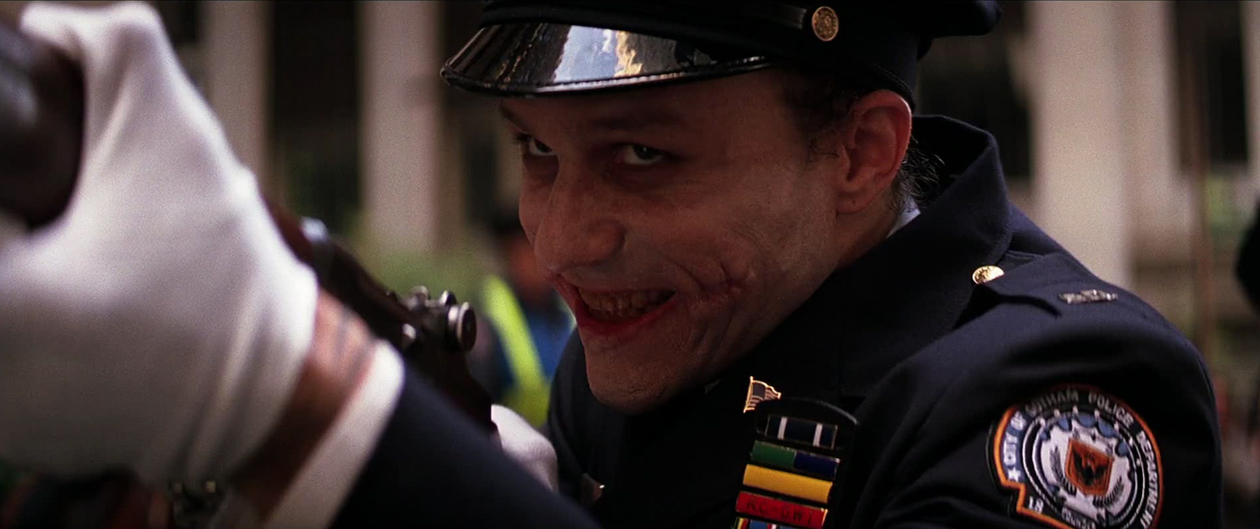

Heath Ledger best captures the insanity and confusion of The Joker in the Dark Knight movie directed by Christopher Nolan. It is arguably the best portrayal of any superhero villain ever.

In the movie, Nolan leaves many crucial hints that proves Joker’s military backgrounds. From the ease of planting the bombs to his efficiency in handling rifles, The Joker gives us all indicators of him being a war veteran. This theory hypothesizes that Joker may have been a war veteran with PTSD, explaining his comfort with and access to all that military-grade weaponry.

### **Joker is an immortal demon with connections to The League of Shadows**

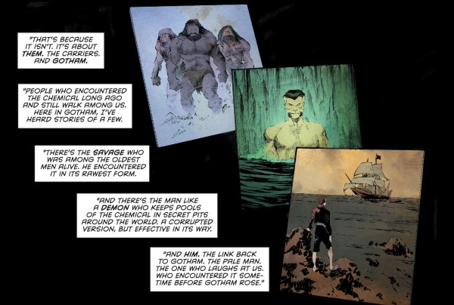

Joker suffers so much physical trauma, one death after another yet he is always back up on his feet for his next joke. From falling into toxic chemicals to burning buildings, how do you think he’s able to do that?

The *Endgame* storyline proposes that throughout Gotham's history, countless inhabitants have fallen prey to a terrifying white demon called the Pale Man of Gotham City. It is speculated that the Pale Man was once a regular human who came into contact with a chemical compound named dionesium, one of the main ingredients in Ra's al Ghul's Lazarus Pits, which then rendered him immortal. Since his exposure to dionesium, the Pale Man, as we know as ‘The Joker’ has haunted Gotham for generations, like a mystical Jack the Ripper, always emerging during the city's most catastrophic events.

### **Joker is actually the elder brother of Bruce Wayne**

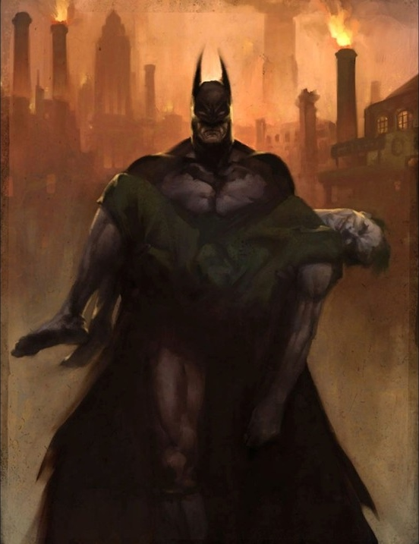

How about a twist– What if The Joker was none other than Thomas Jr., eldest son of Billionaire philanthropist Thomas Wayne?

In this theory, The Joker is secretly Thomas Wayne Jr., Bruce's long lost older brother. Many shreds of evidence point to the existence of a certain “Thomas Jr.,“ a firstborn that dies as an infant usually from a brain injury. It suggests that Thomas Jr. was stolen at an early age, presumed dead, and spent much of his early life suffering from locked-in syndrome as a result of his brain injury.

This theory gained traction among online users and answered a big question– Why Batman never killed Joker?

*It was probably because he was his brother.*

### **Martha Wayne loses her sanity and turns Joker**

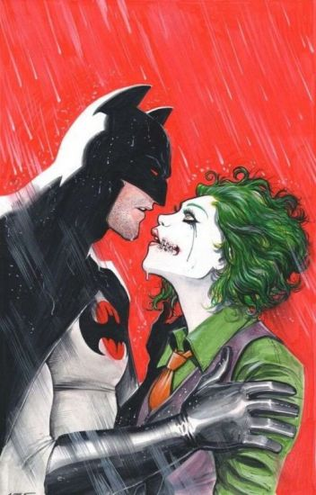

According to the Flashpoint Paradox, this storyline takes place in an alternate universe where Bruce Wayne is shot instead of his parents Thomas and Martha Wayne.

Unable to bear the shock, Thomas Wayne would become a recluse, dedicate himself to avenging his lost son, and become a dark and murderous incarnation of Batman. Martha, on the other hand, would snap and lose herself. She’d slice her cheeks in rage and become the Joker in the Flashpoint timeline. She obviously, is at loggerheads with Batman and the deep antagonism between them creates a rift that is beyond mending.

### 

### 

### **Alfred, the loyal butler, is the real Joker**

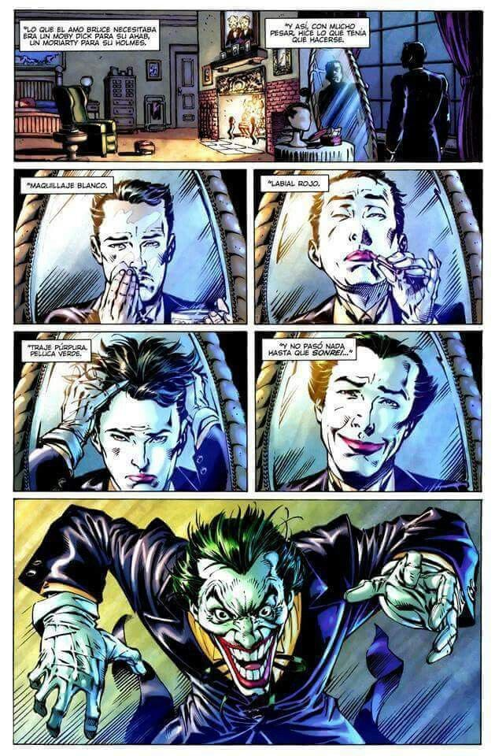

The most bizarre possibility in the list, this wild twist was presented in Neil Gaiman's *Whatever Happened to the Caped Crusader?* a comic that was specifically written to be the "last" Batman comic.

In the comic, Batman has seemingly died (but watches his own funeral proceed). Bruce’s Visitors, friends, and his only family, Alfred are lined up, taking turns at speaking at his funeral. However, things start getting weird when the mic is handed over to Alfred. He starts normally, describing ‘Master’ Wayne as a young vigilante failing miserably to being the caped crusader that Gotham believes in, but then, in a series of startling revelation, he explains how he went on to dress up as Joker just to rekindle Batman’s spirits so that the Dark Knight never feels down. He dons white face paint, red lipstick, and a devious smile to transform himself into the Joker, giving Bruce the archenemy he has needed all along.